Preparing for SMS Texting Attendance

Get Participants Ready
Before your participants can check in or claim credit for the session, they should:
- Have a UCSF CE Portal CloudCME® account.
- Have a completed profile that includes degree, profession, and any credentialing board information.
- Pair their mobile phone by texting their account email address to (833) 992-1812.
You can refer learners to the UCSF CE Portal page with instructions or distribute the SMS Texting Attendance Guide, downloadable from the website. You can also use the downloadable sample slides to guide participants before or after the session.

Note: texting windows open typically after the session starts and remain open up to 6 days afterwards. If a participant misses the window, they may still be able to claim credit in the CE Portal or mobile app.

Get the Session Ready
To obtain the Activity Code for a specific session:
- Navigate to your RSS Dashboard in the CE Portal and search for your series.
- Find the “Child ID:” number in the second column for that session. This is your Activity Code for claiming credit.
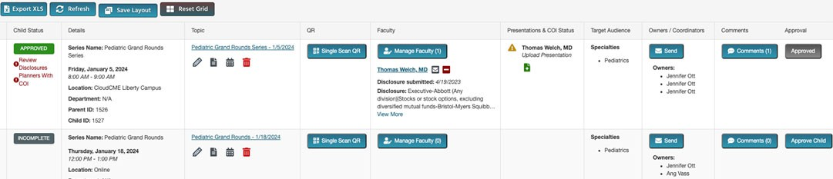

During or after the session, provide the Activity Code for learners to text to the same number. This will record their attendance with credit.

